October 19th 2020 Hilliard Davidson Boys Cross Country Report
OCC Championships 49 degrees with a dew point 40. Cool.

Name 1M 2M 5K Place Speed PR Improve
1. Connor Ackley-10 4:43 9:56 15:38 1 185 14:59 1st Team OCC
2. Nick Puhl-11 4:57 10:07 15:46 2 176 15:27 1st Team OCC
3. Brody Boyd-9 5:00 10:23 16:21 8 163 16:15 2nd Team OCC
4. RJ Sagrilla-12 5:05 10:35 16:35 10 161 16:24 2nd Team OCC
5. Alex Hudson-11 5:03 10:32 16:39 11 153+ 16:36 2nd Team OCC
6. Noah Pease-12 5:05 10:35 16:39 12 163 16:08 2nd Team OCC
7. Nate Gilbert-12 5:00 10:34 16:46 15 160 16:36 3rd Team OCC
8. Alexander Kafka-10 5:14 10:45 16:51 17 155 16:29 3rd Team OCC
9. Adam Alsko-12 5:11 10:45 16:53 20 146 16:53 3rd Team OCC
10. Zach Whitney-11 5:16 11:03 17:23 O-1 141+ 17:11 OCC OPEN Champion
11. Ryan Clark-10 5:21 11:10 17:38 O-2 137 17:28 OCC OPEN Runner Up
12. Henry Byrne-12 5:21 11:10 17:39 O-3 138 17:27 OCC OPEN Third Place
13. Jay Chung-12 5:20 11:10 17:40 O-4 139 17:19 OCC OPEN Fourth Place
14. Brady Whiteside-11 5:19 11:11 17:41 O-6 134 17:33
15. Aaron Egolf-10 5:17 11:18 17:55 45 145 17:11
16. Toby Banks-10 5:25 11:26 18:03 O-11 18:02
17. Jackson Wickham-10 5:22 11:23 18:08 O-13 18:07
18. Archith Yogith-10 5:37 12:02 18:59 O-42 18:22
19. AJ Hoying-12 5:48 12:13 19:12 O-54 18:55
20. Colin Schleappi-12 5:33 12:16 19:21 O-62 19:12
21. Nathan Hand-11 5:43 12:20 19:46 O-75 18:53
22. Zach DeSilva-10 6:14 12:39 19:52 O-84 19:39
23. Brayden Kulesza-12 6:06 12:43 19:54 O-87 19:16
24. Owen Schnipke-10 6:12 12:37 20:01 O-91 18:27
25. Tyler Schmidt-12 5:51 12:30 20:04 O-92 18:38
26. Ryan Zmuda-11 6:11 12:50 20:05 O-93 20:05
27. Carter Davis-10 5:52 12:41 20:13 O-97 20:04
28. Luke Banyots-9 6:41 14:07 22:36 O-114 22:36

OCC Recap:The OCC race was a race of emotions and every year we remember all those runners that ran before us and dedicate this race to our seniors. Running for a team make everyone feel accountable and Davidson rises to the occasion every year. The training was stiff this week but the result was a tight pack with the front of the race getting out fast to prepare for the upcoming meets. Connor Ackley-10 was expected to take the race out hard to string the field. This fast opening pace laid the ground work for Nick Puhl-11 to overtake the two Coffman runners and secure a runner up finish (15:46) behind champion, Connor Ackley-10 in 15:38. The great part of the race was Davidson runners 3 through 7. It was here that Brody Boyd-9 forged ahead and pulled everyone through the mile and two mile in 5:00 to 5:05 and 10:23 to10:35. Our pack had a solid run with a bit of a mental break in the last 1000 meters. Brody Boyd-9 had first team OCC honor taken from him in the last 100 meters fall in from6th to 8th place in 16:21. Next was RJ Sagrilla-12 in 10th place at 16:35 followed by 11th and 12 place finishers Alex Hudson-11 16:39 and Noah Pease-12 in 16:39 rounding out the Davidson team was Nate Gilbert-12 in 15th place in 16:46. Congrats to Zach Whitney-11for his OCC Open Championship (17:23) and leading his team to a low score of 16 points. Ryan Clark-10 was 2nd in 17:38. Henry Byrne-12 was 3rd in 17:39 and Jay Chung was 4th in 17:40.
Puhl-- # 3 #4 #5
Central Ohio 15:47-16:20= 33 sec 16:24= 37 sec 16:29= 42 sec
Celtic Clash 15:27-16:08= 41 sec 16:15= 48 sec 16:29= 62 sec
Midwest 15:55-16:26= 31 sec 16:26= 31 sec 16:32= 37 sec Best showing
OCC 15:46-16:21= 35 sec 16:35= 49 sec -- 16:39= 53 sec too much by 60 sec from Ackley.

Davidson Stats: Champions 6 Teams 16:12 average
Record: 5 Wins 0 Lost Total Record 53 Wins 1 Lost
Split:15:38 to 16:39 = :60 Score: 1, 2, 8, 10, 11 = 32 points
Scores: 1. Hilliard Davidson-32 2. Dublin Coffman-68 3. Orange-86 4. Upper Arlington-90

District Schedule-See parent email for spectator information
12:20 PM Arrive at camp. RJ, get tarp set up early.
2:00 PM Boys Varsity

District Varsity:Connor Ackley-10, Nick Puhl-11, Noah Pease-12, Brody Boyd-9, Nate Gilbert-12, RJ Sagrilla-12, Alex Hudson-11, Alternate; Alexander Kafka-10

Travel Team:Now POD 2: Alsko-12, Whitney-11, Clark-10, Byrne-12, Chung-12, Whitside-11, Egolf-10, Banks-10, Wickham-10, Yogith-10, Schnipke-10 This group will practice with the varsity but will be at all times 7 feet away from the coaches and the Varsity team. This is to ensure that we stay as safe as we can until the state meet is over. All other runner will run on their own and are able to run the Friday evening district race; they will also stay far from Varsity and POD 2.

Friday October 23rd Davidson District JV Race (Davidson, Orange, Lancaster & Coffman)
5:00 PM Boys JV Race
5:30 PM Girls JV Race

Parents:Please help us to run a quick easy meet. Please arrive at 4 with your mask on to do a job similar that the Hot Summer Bash. We will meet the Bus and show them to the spot. We will make sure the course is marshalled we get runners from the finish line to their camps. There are NO SPECTATORS, so our parents get to watch their kids run while helping with the meet.
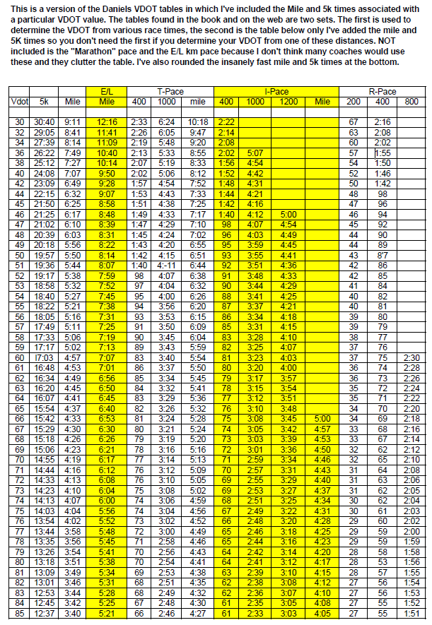

2 mile VO2, 1200I, 2x1000. Tuesday October 20th 2020
Name |  |  | 1600 | 3200 | 1200 | 1000 | 1000
Connor Ackley-10 | 70 | 69-70
Nate Gilbert-12 | 64+ | 74
Nick Puhl-11 | 68 | 73
RJ Sagrilla-12 | 64+ | 74
Noah Pease-12 | 65 | 74
Brody Boyd-9 | 65 | 75
Alexander Kafka-10 | 64 | 76
Alex Hudson-11 | 64 | 74
 |  |  | 1600 | 1.5M | 1000 | 1000 | 1000
Aaron Egolf-10 | 61 | 80
Zach Whitney-11 | 61 | 80
Adam Alsko-12 | 61 | 80
Jay Chung-12 | 61 | 80
Henry Byrne-12 | 61 | 80
Ryan Clark-10 | 61 | 80
Jackson Wickham-10 | 59 | 83
Owen Schnipke-10 | 58 | 84
Toby Banks-10 | 58 | 84
Brady Whiteside-11 | 60 | 80
Archith Yogith-10 | 57 | 84
 |  |  | 1000 | 1000 | 1000
AJ Hoying-12 | 54 | 88
Tyler Schmidt-12 | 56 | 86
Brayden Kulesza-12 | 52 | 91
 |  |  | 1000 | 1000 | 1000
Nathan Hand-11 | 54 | 88
Zach DeSilva-10 | 52 | 91
Carter Davis-10 | 51 | 92
Ryan Zmuda-11
Colin Schleappi-12 | 52 | 91
Luke Banyots-9 | 44 | 1:44

